# AEM CC User-01.png

**Control Centre Module**

Ship side application to enable business users to carry out back office operations including manual syncing of AEM master content/images, carousel and banner images

Table of Contents

**1. Login Page 4**

**2. Bookings 5**

**3. Kiosk Status 6**

**4. Bulletins 7**

**5. Kiosk Start Page T&C 8**

**6. Booking Confirmation T&C 9**

**7. Activity Specific T&C 10**

**8. Reset Password 11**

# 1. Login Page

You can use the Login screen to enter the appropriate email address and password to login.

If you forgot your password, enter your email address and use "**Forgot Password?**" link to recover the password.

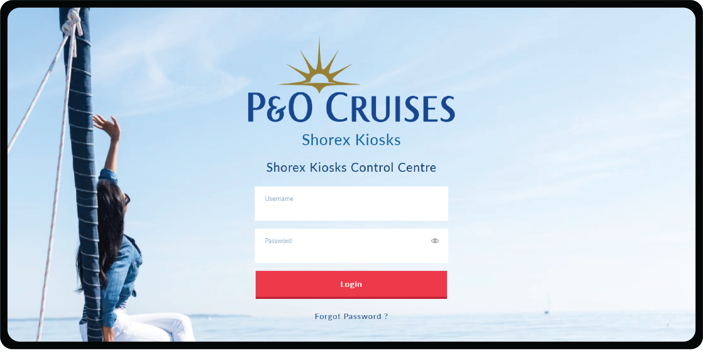

# 2. Bookings

Tour codes can be used to search the specific booking information from the booking table.

Booking updates and other information’s about the booking will be viewed in the table.

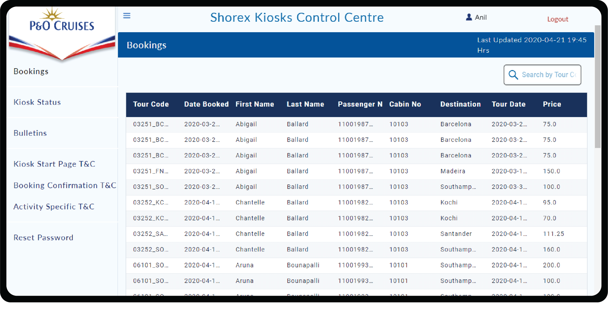

# 3. Kiosk Status

Kiosks status can be monitored in the table along with IP Address and can be rebooted by pressing Reboot Device icon.

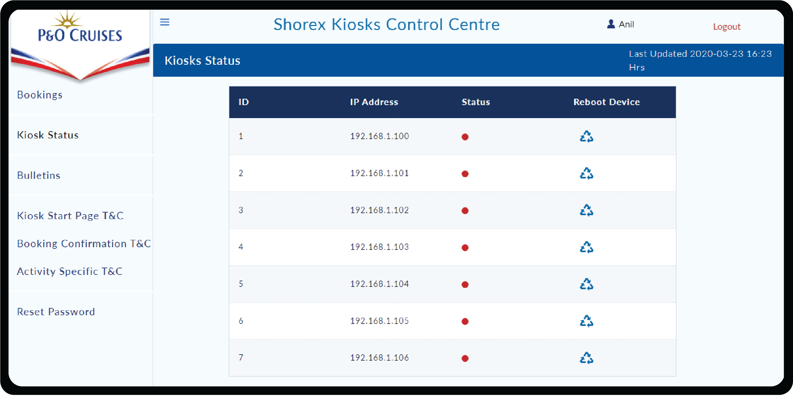

# 4. Bulletins

User can add/update the Bulletins for the imported excursions.

Bulletins can be set visible for a certain period of time, until then it will be in "Active" state. All Active bulletins will be displayed on top of the Bulletin table.

Once after the bulletin end date, the status turned to "**Expired**".

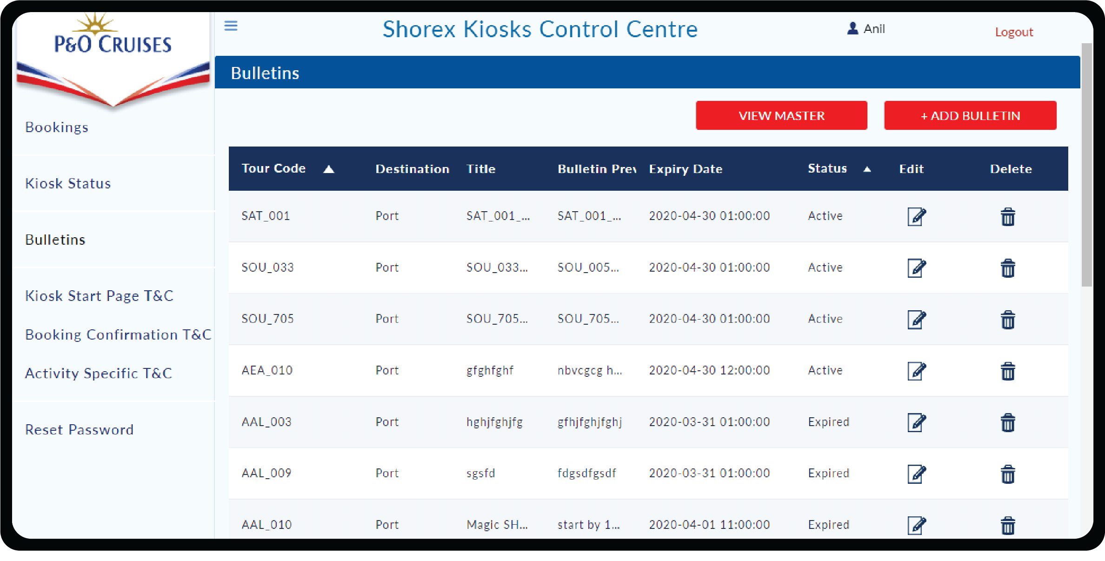

View Master will display the availability of bulletin for all imported excursions.

User has the option to add\edit\delete bulletin from view master page also.

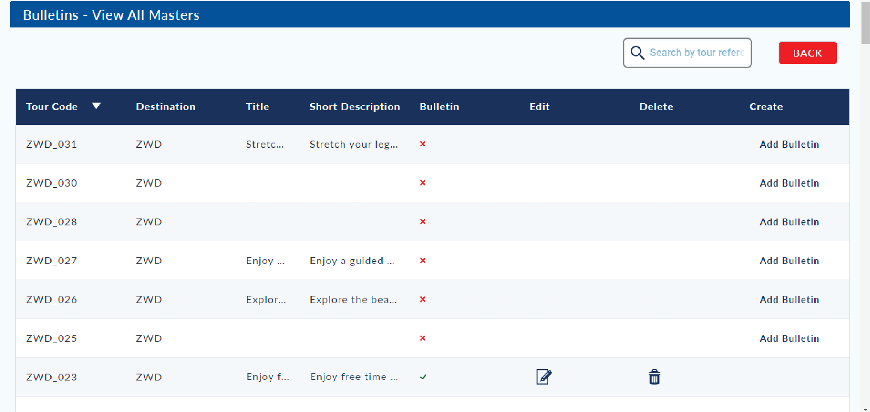

# 5. Kiosk Start Page T&C

Terms and Conditions of the Kiosk start page can be edited and updated by using the **edit** button.

Click on **Save** button to save the updated Terms & Conditions.

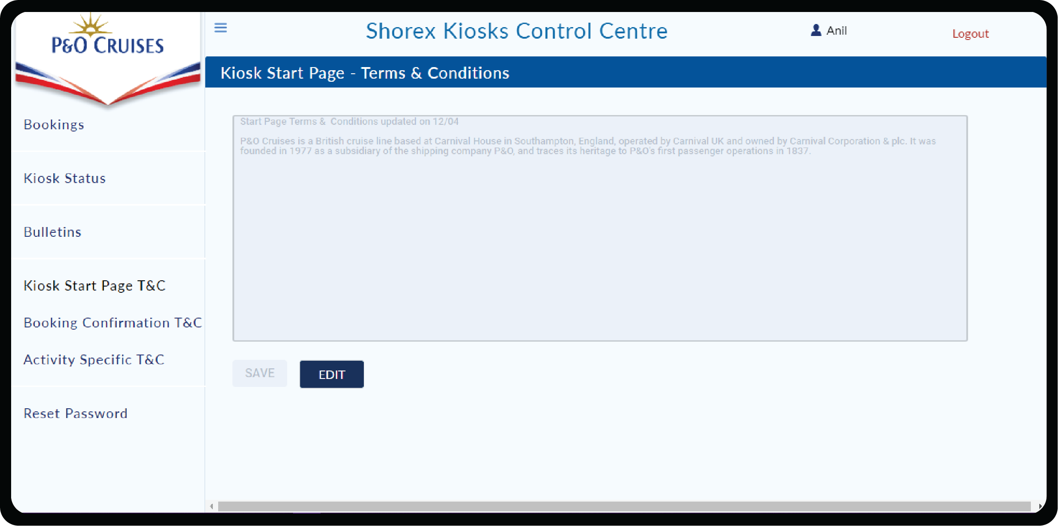

# 6. Booking Confirmation T&C

Terms and Conditions of the Booking confirmation can be edited and updated by using the **edit** button.

Click on **Save** button to save the updated Terms & Conditions.

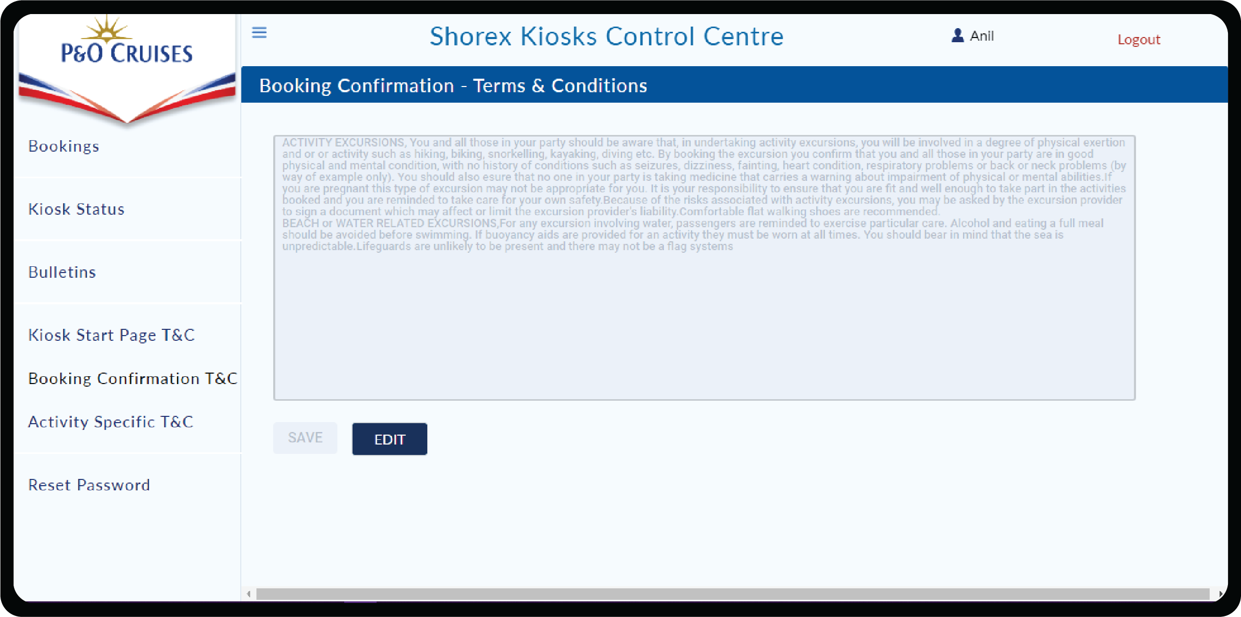

# 7. Activity Specific T&C

Terms and Conditions of the Activity specific can be edited and updated by using the **edit** button.

Click on **Save** button to save the updated Terms & Conditions.

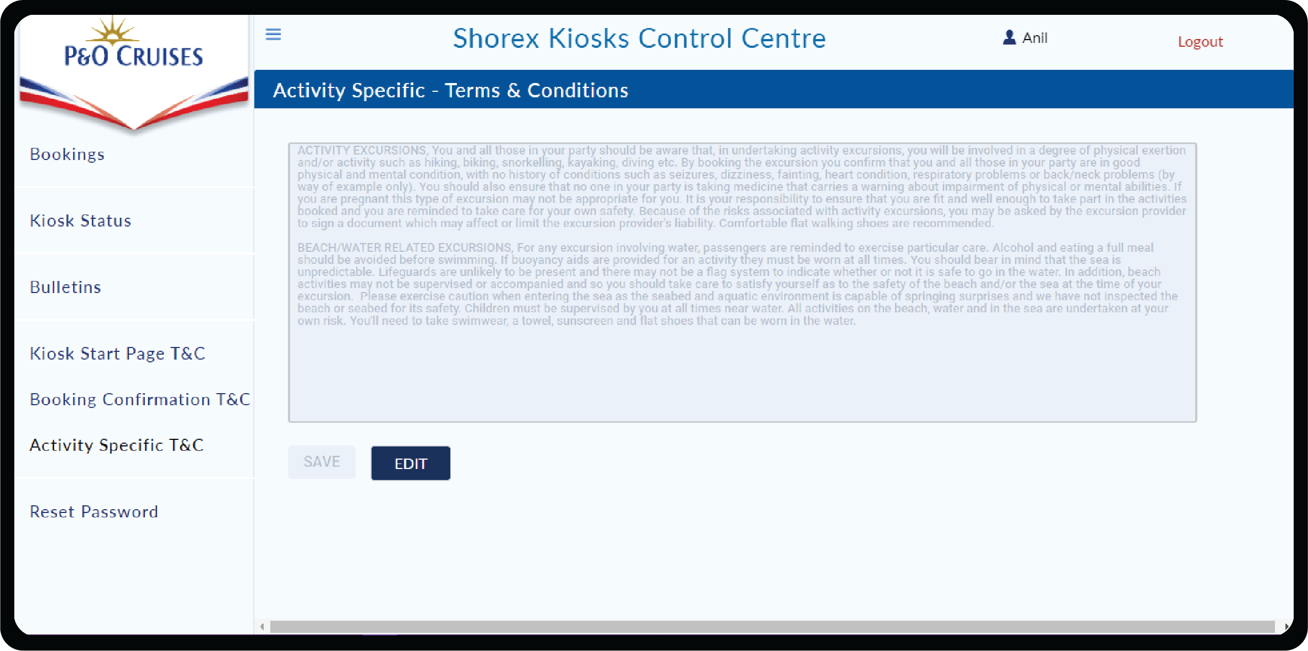

# 8. Reset Password

Reset Password, facilitates the logged on user to change the password.

In order to reset, you need to enter Current Password, New Password and Confirm Password and click Reset button. You can login with new password during the next login.

